**ABSTRACT**

The fluctuation in the fuel price is always the matter of concern in any economy. Crude oil is the raw natural resource that is extracted from the earth and refined into products such as jet fuel, gasoline and other petroleum products. It is one of the world’s most precious commodities. Gradually with time, year-by-year, oil seems to be playing an even greater role in global economy, which has led to its highly complex market and pricing system. This paper investigates the effects of both petrol price and diesel price in the gdp growth of the country using simple linear regression analysis. There are five major factors that play a role in the fluctuation in oil prices: global and Oil Production and Exporting Countries (OPEC’s) production rates, global oil consumption, refinery capacities and geopolitics. This analysis used a simple linear reagression on python to find the effect of dependent variable and on the independent variables.

**INTRODUCTION**

Crude oil is one of the most important energy sources used globally. The role of crude oil over the past two centuries for energy generation which is instrumental in the industrial, domestic, transportation, economic sector and to a large extent almost all activities of the modern-day hydrocarbon society as a source of non-renewable energy has undoubtedly been phenomenal. According to BP Statistical Review of World Energy in June 2019, oil consumption grew by an above average of 1.4 million barrels per day(b/d), or 1.5%.

The origin of crude oil can be traced back to Baku in 1837, where the first commercial oil refinery was established to distil oil into paraffin (used as lamp and heating oil). Crude oil market began around the 1860s after the successful drilling of the first oil well by Col. Edwin Drake in 1859 at Oil Creek near Titusville, West Pennsylvania. Since then, the importance of oil has been increasing. The emergence of crude oil as a highly sought-after global commodity and its ever-increasing demand has accounted for its market complexity and fluctuating prices. Various researchers have suggested a number of entities such as oil production rates, the OPEC, stockholders and large oil companies as determinants of crude oil prices. Other factors include the access of resources, increasing demand driven by economic and industrial growth, geopolitical and economic events, net importing oil countries, value of the dollar, other sources of energy, weather and natural disasters.

As a consequence of global lockdown, 57% of global oil demand has decreased at an unmatched scale. Road transportation in the regions that have been locked down has dropped between 50% and 75%, with average road transport activity almost dropping down to 50%, of the 2019 level, globally by the end of March 2020. Air travel in certain regions has almost come to a standstill, with airmanship activities in some European countries reducing to more than 90%. Aviation activities in China have bounded slightly from the low at the end of February, as lockdown measures have eased slightly. Nonetheless, as lockdowns spread, global aviation activities have declined a staggering 60% by the end of Q1 2020. As a result of decrease in mobility, in March alone world oil demand plummeted by a record 10.8 mb/d year-on-year.

The fuel sector plays the vital significant role in the economy of a country. It is inevitable for the developmental activities of the country. If a country is in a developing process, without the availability of fuel the developing process such as infrastructure maintenance, quick transportation is unimaginable. The manufacturing and cultivating process will not move forward if the fuel energy is insufficient. But unfortunately, the world is facing the huge crisis of fuel. the need for fuel is always above its availability. Hence the price for fuel such as petrol and diesel are considered as the center of the attraction of the growth of any country in the world. The large demand for fuel makes the economy highly sensitive to the changes to fuel prices. The fuel price is increasing from 1986 followed by gulf war in 1990’s . in 2008, world has come across a severe financial crisis and at that time the fuel price was in peek. Fuel price have fallen over 57 percent June 2014 to January 2015. the organization of petroleum exporting countries (OPEC) plays an important role in the stability and volatility of the fuel prices. As of September 2018, the OPEC countries contribute about 44 percent of global oil production and 81.5 percent of proven oil reserves, which makes it as the major influencer global fuel price. among the OPEC countries Saudi Arabia is the largest share holder.by increasing and decreasing the supply of oil they regulate the price of crude. This is done by the spare capacity of them. Indian economy is highly dependent on import of crude oil to meet the energy needs of the country. So that the international prices highly influence the domestic economy. this project will take a look of relationship between the fuel prices and gross domestic product (GDP) of India using simple linear regression in python.

**TABLE 1: Annual Average Nominal petrol Prices for The Period 2003-2022(rs/litre)**

|  |  |
| --- | --- |
| **year** | **Nominal price** |
| **2003** | **33.49** |
| **2004** | **35.71** |
| **2005** | **37.99** |
| **2006** | **43.5** |
| **2007** | **43** |
| **2008** | **45.5** |
| **2009** | **44.7** |
| **2010** | **48** |
| **2011** | **58.5** |
| **2012** | **65.6** |
| **2013** | **66.09** |
| **2014** | **72.26** |
| **2015** | **60.49** |
| **2016** | **59.68** |
| **2017** | **63.09** |
| **2018** | **75.55** |
| **2019** | **72.96** |
| **2020** | **79.76** |
| **2021** | **105.41** |
| **2022** | **96.72** |
|  |  |

**TABLE 2: Annual Average Nominal diesel Prices for The Period 2003-2022(rs/litre)**

|  |  |
| --- | --- |
| **year** | **Nominal price** |
| **2003** | **22.12** |
| **2004** | **22.74** |
| **2005** | **28.22** |
| **2006** | **30.45** |
| **2007** | **30.25** |
| **2008** | **31.76** |
| **2009** | **30.86** |
| **2010** | **38.1** |
| **2011** | **37.75** |
| **2012** | **40.91** |
| **2013** | **48.63** |
| **2014** | **55.48** |
| **2015** | **49.71** |
| **2016** | **48.33** |
| **2017** | **53.33** |
| **2018** | **67.38** |
| **2019** | **66.69** |
| **2020** | **79.88** |
| **2021** | **89.36** |
| **2022** | **96.67** |

**METHODOLOGY**

In this project we are going to find the simple linear regression of effect of petrol price and diesel price in the Indian economy. Where we can find the intercept and coefficient, with what we will be able to predict the GDP growth of the country for any petrol and diesel price.

• To study the overall analysis of oscillation of price of fuel in India

• Then to study the influence of the fuel price in the GDP growth of country.

• Using simple linear regression on the fuel price and GDP growth to find their relationship with each other.

• In this project we are going to use python programming language to find the simple linear regression between the fuel price and GDP growth of the country.

**REVELANCE AND IMPORTANCE:**

According to the United Nations economic and social commission for Asia and pacific (UNESCAP) the use of energy found in nature i.e., primary energy such as fuels has increased four times from 1971 to 2009. The fuel use of consumers in the future expected to be in peek to coincide with the growth target of any country in the world. The government of India was using administered pricing mechanism for fuel pricing still 2014. the government of India in 2014 announced the deregulation of diesel price. This issue was creating a dilemma among the policy makers. because they had the responsibility to make sure the welfare of the common public by giving them fossil fuel in an affordable cost, at the same time they need to ensure that the GDP growth of the country is in descent range. To maintain this two at the same time is near to impossible task. The government gave subsidies to the oil manufacturing companies (OMC) in order to compensate with the price difference between they sell and they want to charge for it. the administration of petrol price was still 2010 and after that it was liberalized. Since in the presence of subsidy the price of fuel was minimal, and the domestic and international price was moving so close. the international fuel price was increasing sharply during 2007 and 2008, which in turn resulted in the increase in the amount of subsidy. still 2014, the diesel price was regulated by the government of India. during 2007 and 2008, the diesel price is also in its peak. in 2012 the diesel price increased by rs.3.5. the economy of India is the seventh largest by the nominal GDP and the third largest by purchasing power parity (PPP). India is one of the G20 countries, a member of BRICS and a developing economy among the top 20 global traders .in India, the agriculture sector contribute about 20.19 % of the GDP growth of the country, the service sector contributes about 53.89% of the GDP growth of the country and the industry sector contributes about 25.92% of GDP growth of the country. as we all know the fuel plays a major role in all in this sector for its development. hence in this project statistically we are going to analyses the effect of fuel price in the economy of India.

**CRUDE OIL PRICE FLUCTUATION AND PETROL PRICE IN INDIA:**

The price of crude oil was in a continuous fluctuation in India due to various factors such a political and seasonal changes. the average change in the crude oil price is mainly affected by the political decision, the demand of the crude oil is mainly maintained by the economy development of the India. the below figure shows the trend of petrol price in India from 2003 to 2022.

. 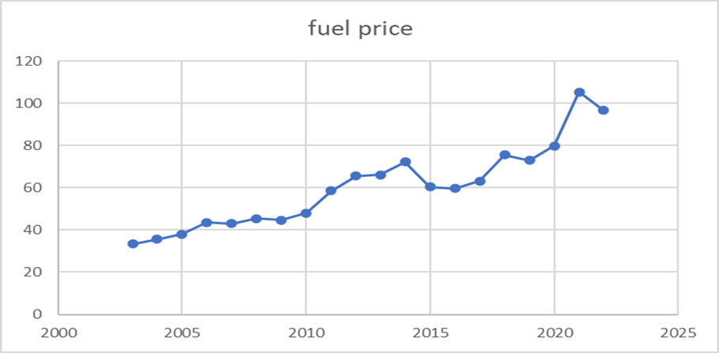

In this above picture we see that the fuel price is in steady growth from 2003 – 2022. this indicates that the demand of petrol was increasing in a steady process without any downfall.

**DIESEL PRICE IN INDIA:**

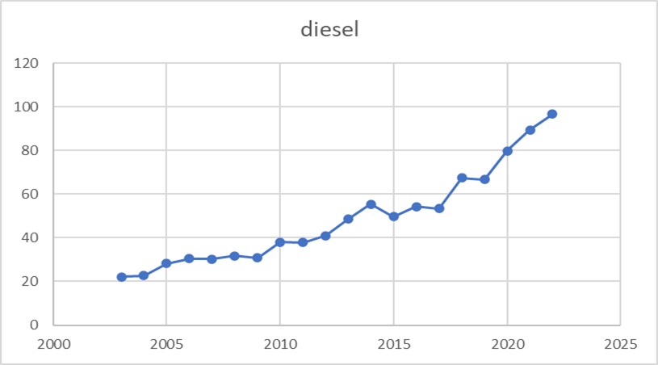

The above figure shows the movement of diesel price from 2003-2022. we are able to clearly observe that the price is increasing in a steady manner from the beginning to the end of the period. We can see that the price of diesel is moving in a slow pace, but whereas the price of the petrol changes rapidly. the rapid rise in the petrol price is due to the deregulation that came into effect in 2010. while in case of diesel the complete deregulation came into effect only in 2014, that is the reason of its gradual increase.

**GDP GROWTH OF THE COUNTRY:**

The gross domestic product (GDP) is used to measure the economy, it is used to measure the growth or downfall of the economy of the country .it is not only used to indicate the economy of the country, it is also used to indicate the living standard of the people i.e., the GDP increases the living standard of the people increases. according to the ministry of finance of government of India the annual growth rate of Indian economy is projected to have increased to 7.4% in the fiscal year 2014-2015 as compared with 6.9% in the fiscal year 2013-2014. In the annual report, International Monetary Fund (IMF) forecast economy of India would grow by 7.5% percent in the fiscal year 2015-2016 starting on April 1 ,2015 and ends at march 31,2016. the below graph shows the GDP growth of the country from 2003 -2022.

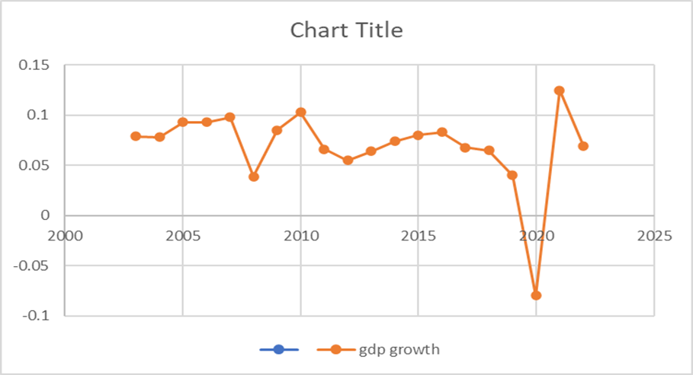

We can see from the above graph that the economy of India is suffered from severe decline in the year 2020, this is due to nothing but covid -19. covid -19 was a great disturbance to Indian economy. In the fourth quarter of the fiscal year 2020 i.e., from December 2020 to march 2021 the Indian economy has gone down about 3.1%. after the announcement of the economy package in the middle of May, India’s GDP went down estimated further into the negative figures, signalling a deep recession for the nation. Credit Rating Information Services of India Limited (CRISIL) has declared this as the India’s worst recession period ever since its independence in the year of 1947.

**STATISTICAL ANALYSIS OF FUEL PRICE AND GDP GROWTH IN PYTHON:**

in this project, we are going to use regression analysis in the method of machine learning in the python programming language. with this we can find the effect of petrol and diesel price on GDP growth.

Simple linear regression of petrol price on GDP growth:

STEP:1: to read the excel file

Input:

import pandas as pd

df = pd.read_excel(r'C:/Users/user/Downloads/finaldata.xlsx')

explanation:

pandas is the one of the most powerful open source library in the python programming language . it is the best library to use if we are working on a tabular data like comma separated value,excel file.here I have imported pandas because I have stored my data in a tabular form in the excel sheet .in this step , we are readind the data that is stored in the excel file in a tabular form using pandas.

STEP:2: to visualize the head

Input :

df.head()

output :

year petrol price GDP growth

0 2003 33.49 0.079

1 2004 35.71 0.078

2 2005 37.99 0.093

3 2006 43.50 0.093

4 2007 43.00 0.098

Explanation:

This step is used to just verify whether the correct dataset is read by python . the command head() is used to visualize the first five row of the dataset and tail() is used to visualize the last five row of the dataset .

STEP:3:to find the correlation

Input :

A = df

A.corr()

Output :

year petrol price GDP growth

year 1.000000 0.931099 -0.315103

petrol price 0.931099 1.000000 -0.197875

gdp growth -0.315103 -0.197875 1.000000

explanation :

in the first step we have read the excel file in the name df , which we changing in this step as A . next we are finding the correlation of each row in the data set with the other rows in the data set . here we see that every row is perfectly correlated with themselves.

STEP:4: to divide the data for regression:

Input :

Y = A[["gdp growth"]]

X = A.drop(labels=["gdp growth","year"],axis=1)

Explanation:

In this step, we are dividing the data for regression analysis, we are taking the “dependent variable” as gdp growth and “independent variable” as the fuel price.

STEP:5:to find the training and testing set

Input :

from sklearn.model_selection import train_test_split

xtrain,xtest,ytrain,ytest=train_test_split(X,Y,test_size=0.2,random_st ate=21)

output :

1 .xtrain:

petrol price

5 45.50

17 79.76

18 105.41

11 72.26

6 44.70

14 63.09

1 35.71

2 37.99

12 60.49

3 43.50

8 58.50

0 33.49

16 72.96

4 43.00

15 75.55

9 65.60

2.xtest:

petrol price

7 48.00

10 66.09

19 96.72

13 59.68

3.ytrain:

gdp growth

5 0.039

17 -0.080

18 0.125

11 0.074

6 0.085

14 0.068

1 0.078

2 0.093

12 0.080

3 0.093

8 0.066

0 0.079

16 0.040

4 0.098

15 0.065

9 0.055

4.ytest:

gdp growth

7 0.103

10 0.064

19 0.069

13 0.083

Explanation :

In this step we are dividing the data we have collected into training and testing set for both the dependent and independent variable.

STEP:6: create ML model, to train the model and to fetch the value of training results:

Input:

from sklearn.linear_model import LinearRegression

lm = LinearRegression()

model = lm.fit(xtrain,ytrain)

model.intercept_

model.coef_

output :

array([0.09261143])

array([[-0.00045203]])

explanation :

in this step we are finding the value of intercept bₒ = 0.0926114 and the value of coefficient of regression analysis b₁ = -0.00045203

STEP:7: using the retrieved value for making a prediction:

Input:

q = int(input("Enter any value for fuel price : "))

p = -0.00045203*q + 0.09261143

print("Predicted_gdp: ",p)

output:

Enter any value for petrol price:

Answer: petrol price predicted GDP

33 0.0777

36 0.0763

38 0.0754

43 0.0731

44 0.0727

45 0.0723

46 0.0718

59 0.0659

Explanation:

As we knew the value of intercept and coefficient of regression analysis, we can predict the value of gdp for any value of fuel price.

STEP:8 : to find the value of error in training and testing set

Input:

pred = model.predict(xtest[["fuel price"]])

from sklearn.metrics import mean_absolute_error,mean_squared_error

mean_absolute_error(ytest,pred)

output :

0.017705985383603448

Explanation :

In this step we have find the value of mean absolute error of testing set is 0.017705985383603448

STEP:9: to visualize the collected data in graphic form

Input:

import seaborn as sb

sb.regplot(X,Y)

output :

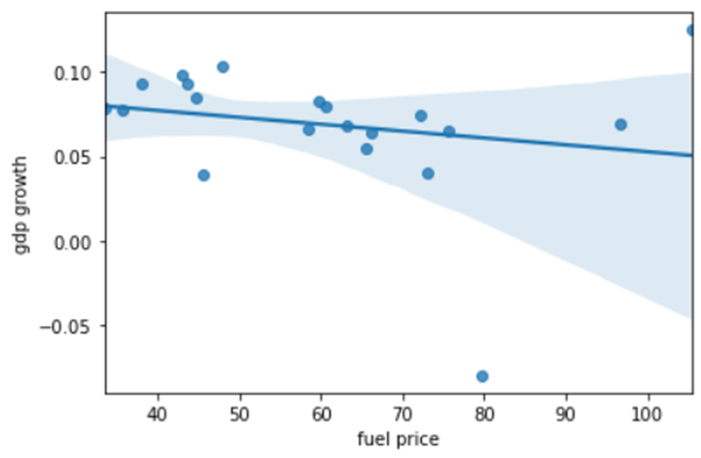

Explanation:

In this picture we can see the clear relationship between the petrol price and GDP growth of collected data

STEP:10:to visualize the result of petrol prize and the predicted GDP growth of the country

Input:

import matplotlib.pyplot as plt

plt.scatter(A.fuelprice,A.gdpgrowth,c="blue")

plt.xlabel("fuelprice")

plt.ylabel("gdpgrowth")

plt.title("fuel vs gdp")

plt.plot(X,-0.00045203*X+0.09261143,c="red")

output:

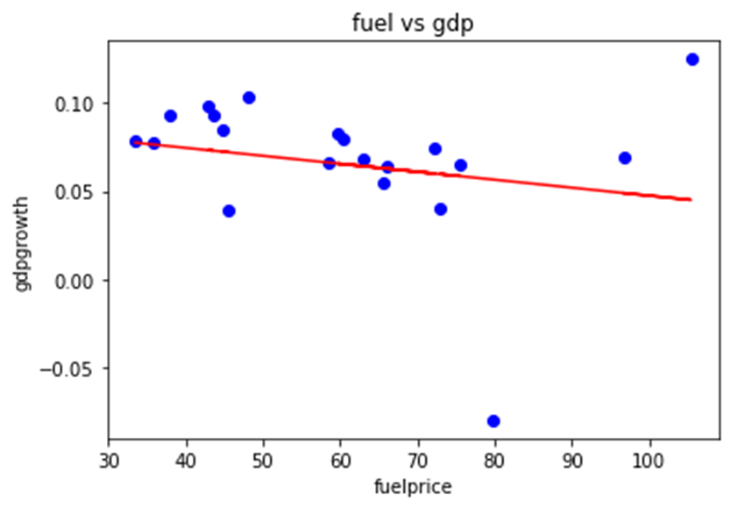

Explanation:

from the above graph and the previous graph, the plotted graph using the direct data and the value we have find using intercept and coefficient is exactly the same

Simple linear regression of diesel price on GDP:

STEP:1: to read the excel file

Input:

import pandas as pd

A = pd.read_excel(r'C:/Users/user/Downloads/dieseldata.xlsx')

explanation:

pandas is the one of the most powerful open source library in the python programming language . it is the best library to use if we are working on a tabular data like comma separated value,excel file.here I have imported pandas because I have stored my data in a tabular form in the excel sheet .in this step , we are readind the data that is stored in the excel file in a tabular form using pandas.

STEP:2: to visualize the head

Input :

A.head()

Output :

year gdpgrowth diesel

0 2003 0.079 22.12

1 2004 0.078 22.74

2 2005 0.093 28.22

3 2006 0.093 30.45

4 2007 0.098 30.25

Explanation:

This step is used to just verify whether the correct dataset is read by python . the command head() is used to visualize the first five row of the dataset and tail() is used to visualize the last five row of the dataset .

STEP:3:to find the correlation

Input :

A.corr()

Output :

year gdpgrowth diesel

year 1.00000 -0.314447 0.946099

gdpgrowth -0.314447 1.000000 -0.290047

diesel 0.946099 -0.290047 1.000000

explanation :

next we are finding the correlation of each row in the data set with the other rows in the data set . here we see that every row is perfectly correlated with themselves.

STEP:4: to divide the data for regression:

Input :

Y = A[["gdpgrowth"]]

X = A.drop(labels=["gdpgrowth","year"],axis=1)

Explanation:

In this step ,we are dividing the data for regression analysis ,we are taking the “dependent variable” as gdp growth and “independent variable” as the diesel price .

STEP:5:to find the training and testing set

Input :

from sklearn.model_selection import train_test_split

xtrain,xtest,ytrain,ytest=train_test_split(X,Y,test_size=0.2,random_st ate=21)

output :

1.xtrain:

diesel

5 31.76

17 79.88

18 89.36

11 55.48

6 30.86

14 53.33

1 22.74

2 28.22

12 49.71

3 30.45

8 37.75

0 22.12

16 66.69

4 30.25

15 67.38

9 40.91

2.ytrain:

gdpgrowth

5 0.039

17 -0.080

18 0.125

11 0.074

6 0.085

14 0.068

1 0.078

2 0.093

12 0.080

3 0.093

8 0.066

0 0.079

16 0.040

4 0.098

15 0.065

9 0.055

3.xtest:

diesel

7 38.10

10 48.63

19 96.67

13 48.33

4.ytest:

gdpgrowth

7 0.100

10 0.064

19 0.069

13 0.083

Explanation :

In this step we are dividing the data we have collected into training and testing set for both the dependent and independent variable.

STEP:6: create ML model, to train the model and to fetch the value of training results:

Input:

from sklearn.linear_model import LinearRegression

lm = LinearRegression()

model = lm.fit(xtrain,ytrain)

model.intercept_

model.coef_

output :

array([0.09897423])

array([[-0.00071325]])

explanation :

in this step we are finding the value of intercept bₒ = 0.09897423 and the value of coefficient of regression analysis b₁ = -0.00071325.

STEP:7: using the retrieved value for making a prediction:

Input:

q = int(input("Enter any value for disel price : "))

p = -0.00071325*q + 0.09897423

print("Predicted_gdp: ",p)

output :

Enter any value for diesel price :

Answer:

Diesel price predicted gdp

22 0.0832

28 0.079

30 0.077

31 0.0768

38 0.0718

40 0.070

48 0.0647

55 0.0579

Explanation :

As we knew the value of intercept and coefficient of regression analysis, we can predict the value of gdp for any value of diseslprice.

STEP:8 : to find the value of error in training and testing set

Input:

pred = model.predict(xtest[["diesel"]])

from sklearn.metrics import mean_absolute_error,mean_squared_error

mean_absolute_error(ytest,pred)

mean_squared_error(ytest,pred)

output :

0.02149060737689287

0.0006641540445133591

Explanation :

In this step we have find the value of mean absolute error of testing set is 0.02149 and mean squared error of the testing set is 0.000664

STEP:9: to visualize the collected data in graphic form

Input:

import seaborn as sb

sb.regplot(X,Y)

output :

<AxesSubplot:xlabel='diesel', ylabel='gdpgrowth'>

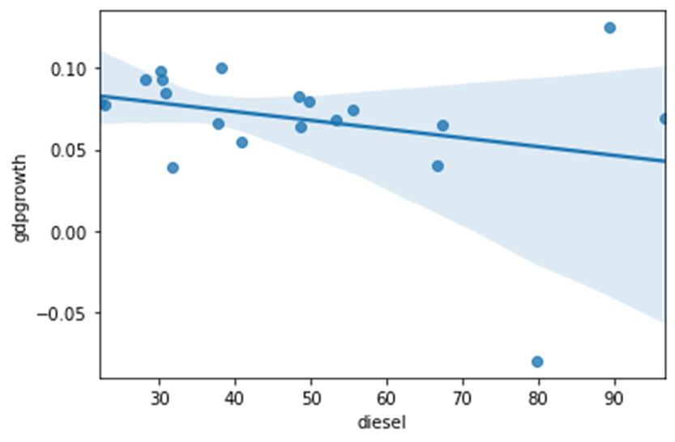

. Explanation :

This image shows the clear relationship between the diesel price and gdp of the collected data

STEP:10:to visualize the result of petrol prize and the predicted gdp growth of the country

Input:

import matplotlib.pyplot as plt

plt.scatter(A.diesel,A.gdpgrowth,c="blue")

plt.xlabel("disel")

plt.ylabel("gdpgrowth")

plt.title("diesel vs gdp")

plt.plot(X,-0.00071325*X+0.09897423,c="red")

output:

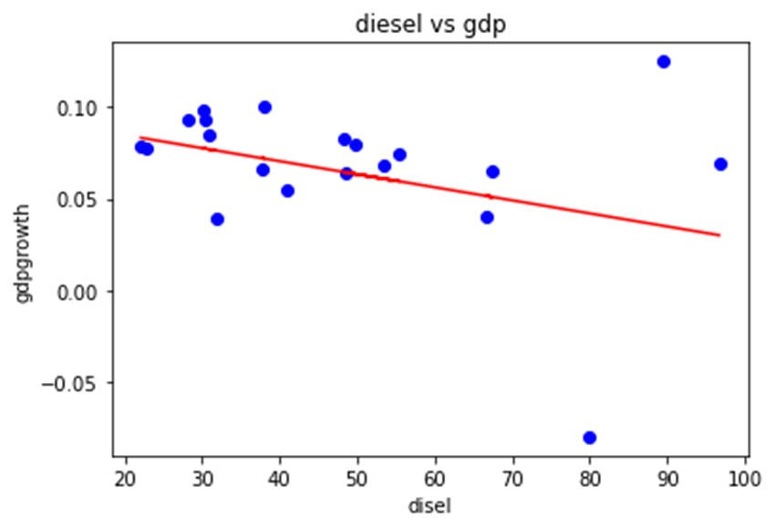

Explanation:

from the above graph and the previous graph, the plotted graph using the direct data and the value we have find using intercept and coefficient is exactly the same

**CONCLUSION**

The above graphs shows the relationship between the diesel price and petrol price with GDP growth . in the above graph x-axis denotes the fuel prices of petrol and diesel and y-axis denotes the GDP growth rate . the relationship between the fuel prices and the GDP growth is above graph is the downward slope. from this graph we can clearly understand that the fuel price increases , the growth rate decreases . the curve is almost flat , which indicates the gdp growth rate don’t show that much response to fuel price . as we can see that when GDP growth is of negative ,the fuel price is so high and when the GDP growth is of high,the fuel price seems to be low. The fuel price along with many other factors affects the growth rate of the country.thus the relation ship between them is when the fuel price increases ,the growth rate of the country decreases.